**COURSE OUTCOME AND PROGRAM OUTCOME ATTAINMENT CALCULATION**

Ajith P1, Karpagamainthan M2, Naveen E3,Dr. S. Prakash4, Dr. R. P. S. Manikandan5

*1,2&3(B. Tech.IT, Sri Shakthi Institute of Engineering and Technology, Coimbatore, Tamil Nadu, India)*

*4(Professor, Sri Shakthi Institute of Engineering and Technology, Coimbatore, Tamil Nadu, India.)*

*5(Associate Professor, Sri Shakthi Institute of Engineering and Technology, Coimbatore, Tamil Nadu, India)*

*Corresponding Author: karpagamainthan****@****gmail.com*

|  |  |
| --- | --- |
| How to cite this paper: Ajith P1, Karpagamainthan M2, Naveen E3, S. Prakash4, R. P. S. Manikandan 5 COURSE OUTCOME AND PROGRAM OUTCOME ATTAINMENT CALCULATION IJIRE-V4 I2,2023  Copyright © 2023 by author(s) and  5th Dimension Research Publication  This work is licensed under the Creative Commons Attribution International License  (CC BY 4.0). <http://creativecommons.org/licenses/by/4.0/> | ***Abstract:*** *The course outcome & program outcome attainment calculation system is a set of tools that enables the teaching staff to create student batches and enter their exam scores on the Web in order to calculate attainment. It enables the college or university to provide an individual user account to each faculty. All the user accounts (Admin and teaching faculty) are password protected. So, the database can be termed as secured. In CO & PO Attainment Calculation Portal, only the administrative section is allowed to create the account, but faculty can register with the application. After creating the account, the user can view his/her detail by using an SQL query. In the existing system, we can store all the records manually in spreadsheets that require large manpower & place to store all the records but it does require only database connectivity to store all the data. It can handle all details about a college mark sheet system. The details include faculty details, subject details, student personnel details, academic details, and exam details. In this, we can implement a facility that a faculty can be able to create a new batch of students, and other faculties who have mapped to handle subjects, can able to access and enter the marks of that batch of students.*  ***Key Word****: Course Outcome, Program Outcome, Direct Attainment, Indirect Attainment, Student Survey Parent Survey, Alumni Survey* |

1. **Introduction**

The CO & PO attainment calculation system is a set of tools that enables the teaching staff to create student batches and enter their exam scores on the web in order to calculate attainment. It enables the college or university to provide an individual user account to each faculty. All the user accounts (Admin and teaching faculty) are password protected. So, the database can be termed as secured. In CO PO Attainment Calculation Portal, only the administrative section is allowed to create the account, but faculty can register with the application. After creating the account, the user can view his/her detail by using an SQL query. In the existing system, we can store all the records manually in spreadsheets that require large manpower & place to store all the records but it does require only database connectivity to store all the data. It can handle all details about a college mark sheet system. The details include faculty details, subject details, student personnel details, academic details, and exam details. In this, we can implement a facility where a faculty can be able to create a new batch of students, and other faculties who have mapped to handle subjects, can able to access and enter the marks of that batch of students.

1. **Proposed Work**

User friendly and new faculty can able to use it with case.No other faculty can edit the mark sheet apart from the respective faculty.Faculty can view mark sheets subject-wise or batch-wise.Need not remember complex formulas and Spreadsheet skills

**Project Flow**

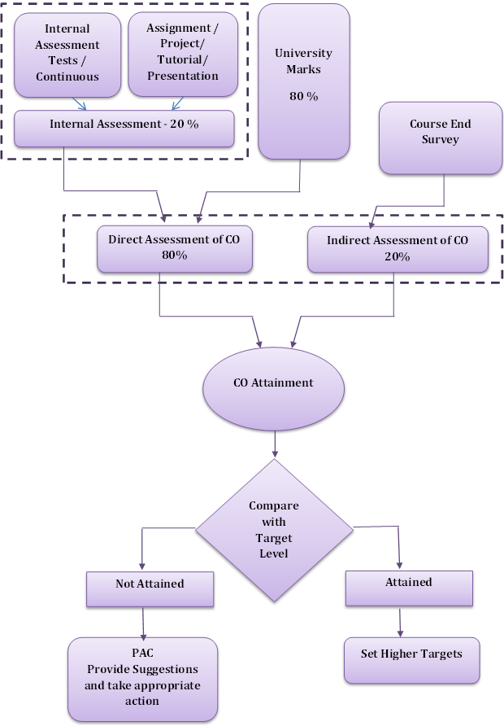

**Fig-1 Final CO Attainment Calculation**

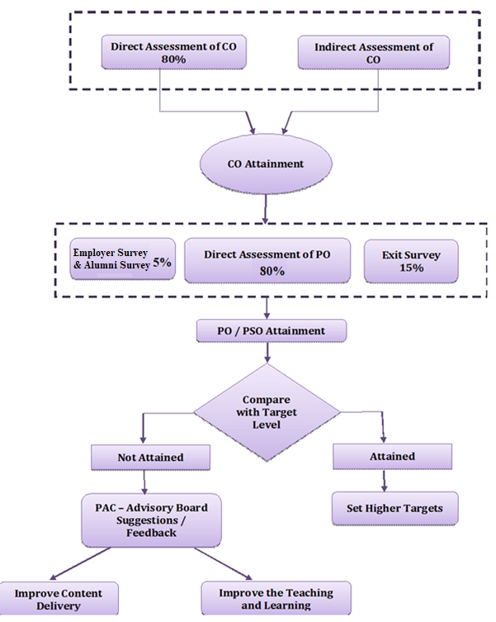

**Fig-2 Final PO Attainment Calculation**

**Design and Implementation**

**Product Features**

The major features are listed below.

1. Unauthorized access is prevented because only authorized or registered users can only process data and access resources.
2. Also, the users who request without login in are also prevented from accessing the data.
3. And even an authorized user can’t view other class mark sheets if he has not asssigned to any subject for the semester to the class.

**Modules**

There are two different modules present in the system each module will have different functionalities to be performed. The different modules are as follows.

**Admin**

The admin has the role of registering faculties with their email and password details.He can able to edit department details and subject details.He can able to view all the marksheets and attainment result.But he can’t edit them.

**Faculty**

The role of the faculty is to create a new batch by providing the batch name and adding students to the batch who can able to drop the class that he/she has to create but can’t able to delete the batch created by another faculty. In a batch, faculty have the right to add semester subjects. They can also able to view other class mark sheets. He can edit and enter student's mark in the respective mark sheets.

**Student**

The role of the student is they can give their feedback for each course in a survey form. For each course outcome, they are given three options satisfied,highly-satisfy, and not-satisfy. Based on their submitting indirect will be calculated.

**Parents and Alumni**

After the end of the program collection of feedback from the parents and alumni. Submitting values are calculated for indirect course outcomes.

**Calculating Process**

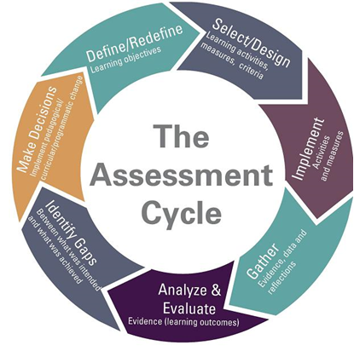**Course outcome Attainment Evaluation Process -** The process used to evaluate the course outcome attainment is explained in the figure below

**Fig-3 Assessment Cycle**

**Select / Define Course Outcome**

1. Every course will have common, core expectations for student learning.
2. These expectations are the most important things a student who passes the course will takeaway from any section of the course.
3. Every course coordinator will define 5 to 6 course outcomes for every course and the course outcomes are validated and approved by the Program Assessment Committee.

**Framing the course outcomes is pictured as follows**

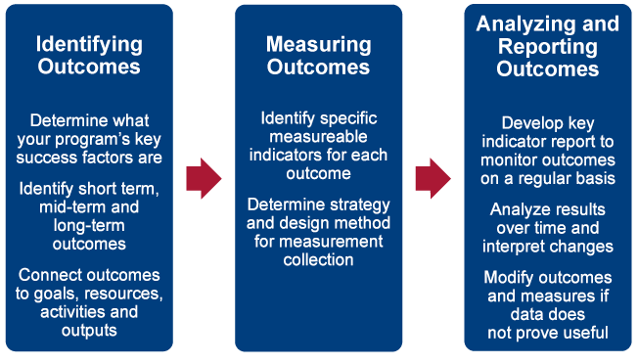

**Fig-4 Define Course Outcome**

**Activities and Measures - Assessment Plan**

The methodology of assessment of every course outcome is planned at the beginning of the course. The different methodology of assessment includes but are not limited to

* Internal Assessment Test
* Quiz
* Seminar
* Assignment
* Project
* Tutorial

The course coordinator prepares a detailed plan specifying the methodology used for assessment. The Program Assessment Committee and the Head of the Department will approve the assessment plan submitted.

**Gathering Evidence data and reflections- Assessment**

The faculty handling the subject will assess the student's skills and learning ability by using the assessment tools and methodologies.

**Analyze and Evaluate**

The results of attainment of course outcome are analyzed and the delivery methodology, content, etc are improved in order to provide a quality education.

**Assessment Methodology**

The course outcomes are evaluated based on the direct and indirect Assessment methods. The direct assessment method uses the following evaluative components.

1. **The Internal Assessment Test** - Internal Assessment Tests(IAT) are conducted for fifty marks three times in the duration of the course. The questions in the IAT are set based on bloom’s taxonomy to evaluate the specific course outcomes.
2. **Assignments/ Projects /Presentation, etc** - Apart from the IATs, the faculty handling the course will evaluate the course outcomes by evaluating the students’ performances in the assignments, projects, presentations, etc. The faculty decides the evaluative component based on the nature of the subject.
3. **End Semester Exam** - Since the college is an affiliated college, the end semester exam is conducted by the University for Hundred Marks. The attainment levels are set and the attainment level is calculated individually for all the IATs, Assignments/Projects/ Presentations and for the university exam. The indirect assessment of the course outcome is done through the survey which is taken at the end of the course.

**Attainment Level**

The attainment levels are set considering the average performance level.

**Attainment level 1:** 60% of students scored more than average percentage marks in the evaluative component

**Attainment level 2:** 70 % of students scored more than average percentage marks in the evaluative component

**Attainment level 3**: 80% of students scored more than average percentage marks in university or set attainment level in the final examination.

**Course Outcome Attainment**

The attainment level is calculated as follows.

1. 80% weightage is given to the direct assessment and 20% weightage is given to the indirect assessment.
2. In direct assessment 80% weightage is given to the end semester examination and 20% weightage is given to internal assessment.
3. The direct assessment formula is given as follows,
4. Direct Assessment=(70% of university level)+(20% of internal level)+(10 % of assignment)
5. The 20 % of indirect assessment is taken from the course end survey.
6. Attainment of Program Outcomes and Program Specific Outcomes Process
7. Outcomes assessment is the process of collecting evidence that indicates the extent to which the program achieves its intentions.
8. Assessment tools are categorized into direct and indirect methods to assess the program educational objectives, program outcomes and course outcomes. And tools are framed on the basis of the Constructive Alignment for the Outcome Based Learning.

**Indirect Assessment**

1. **Program Exit Survey** - The program exit survey identifies twelve broad learning outcomes related to graduate education and asks graduates to indicate the level of preparation provided by their graduate program. This type of survey can also point to areas in which the institution should invest more or fewer resources to enhance a student's learning and development experience.
2. **Alumni Surveys** - The Alumni Survey is designed to allow graduates to reflect upon their years after graduation. This information is used to improve the college experience for future students by identifying strengths in our programs as well as areas that need further development. The survey includes issues relating to satisfaction regarding academic programs, intellectual and personal growth, student services, and preparation for a career.
3. **Employer Surveys** - Provide information about the curriculum, programs, and course outcomes, on-the-job field-specific information about the application and value of the skills that the program offers. It helps to determine if their graduates have the necessary job skills and if there are other skills that employers particularly value that graduates are not acquiring in the program.

**Direct Methods**

Display the student’s knowledge and skills from their performance in the continuous assessment tests, end-semester examinations, presentations, and classroom assignments etc. These methods provide a sampling of what students know and/or can do and provide strong evidence of student learning

**Indirect Methods**

Such as surveys and interviews, and ask the stakeholders to reflect on the student's learning. They assess opinions or thoughts about the graduate’s knowledge or skills. Indirect measures can provide information about graduate’s perceptions of their learning and how different stakeholders value this learning. The following table summarizes the various assessment tools.

**Evaluation of Each PO And PSO**

1. Program outcome attainment levels are set by the program assessment committee for all POs and PSOs. The PO and PSO matrix indicate direct and indirect attainment levels.
2. The average across all the courses addressing PO/PSO gives the direct attainment level of PO/PSO.
3. The student exit surveys, employers’ survey, co-curricular activities, extracurricular activities and many factors give the indirect attainment level of PO/PSO.
4. PO attainment level will be based on the direct and indirect assessment level.
5. Overall attainment level is calculated considering 80% weight age to the direct assessment and 20%.

**Advantages**

The main objective of the course outcome and program outcome is to provide an online base platform for calculating the attainment of students. The following are the advantages of the co&po attainment portal.

* Accessibility
* Exposure
* Paperless
* Time saver
* Communication
* Easy to use and accessible from all devices
* Effective communication and sharing.

1. **Result**

We have developed a web page which contains a few modules which are admin and faculty It can handle all details about a college mark sheet system. The details include faculty details, subject details, student personnel details, academic details, and exam details. In this, we can implement a facility where a faculty can be able to create a new batch of students, and other faculties who have mapped to handle subjects, can able to access and enter the marks of that batch of students.

The admin has the role of registering faculties with their email and password details. He can able to edit department details and subject details. He can able to view all the mark sheets and attainment results. But he can’t edit them.The role of the faculty is to create a new batch by providing the batch name and adding students to the batch who can able to drop the class that he/she has created but can’t able to delete the batch created by another faculty. In a batch, faculty have the right to add semester subjects. They can also able to view other class mark sheets. He can edit and enter students' marks in the respective mark sheets. The role of the student is they can give their feedback for each course in a survey form. Based on their submission indirect will be calculated. After the end of the program collection of feedback form the parents and alumni.Submitting values are calculated for indirect course outcomes.

1. **Conclusion**

The CO-PO attainment calculation system is a set of tools that enables the teaching staff to create student batches and enter their exam scores on the Web in order to calculate attainment. It can handle all details about a college mark sheets system. The details include faculty details, subject details, student personnel details, academic details, and exam details. In this, we can implement a facility that a faculty can be able to create a new batch of students and other faculties who have mapped to handle subjects, can able to access and enter the marks of that batch of students.

**References**

1. <https://www.vrsiddhartha.ac.in/co-po-attainment/>
2. <https://velalarengg.ac.in/governing/insight_co&po.php>.
3. https://youtu.be/2aFzGfxqHuo.
4. https://www.nrtec.in/department-of-eee-co-po-attainment/